Circuit Layout

1. 4 Stepper Motor Controller (DRV8811)
2. Differential Bus Transceiver (SN75176AD)
3. Step Down Switching Regulator (L5970D)
4. USB Interface Converter (RS485A&B)
5. (ATMEGA644A TQFP44)
6. OPTO (x-y-z)
7. Debug LEDs and Reset button
8. Integrated hardware for driving extruder
9. USB connector

Stepper Motor (DRV8811)

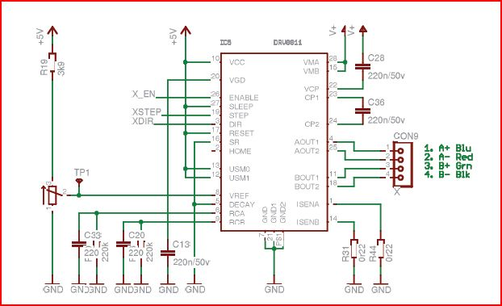

From the circuit layout of Generation 6.

* **Stepper Motor**
* For controlled movement (eg. Rotation angle, speed or position)
* Open loop control
* **Types of Stepper Motor**

1. Variable Reluctance (VR):

<http://www.wisc-online.com/objects/ViewObject.aspx?ID=IAU14208>

1. Permanent-Magnet (PM):

* Low cost; low resolution
* Low torque and large step angle

1. Hybrid

* Step angle (3.6°~0.9°, 100 to 400 steps/rev)
* Provide better performance with torque, speed and resolution
* More expensive than PM stepper motor
* **Torque Generation**

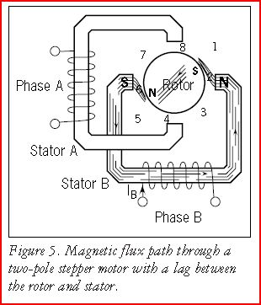

$$H=\left(N×i\right)÷l$$

Where

N = # of winding turns

i = current

l = mangetic flux path length

* **Stepping angles**

$$Step Angle=360°÷(\# of poles per phase ×\# of phases)$$

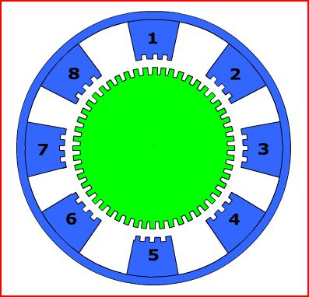

Example:

# of teeth on the green rotor = 50

# of teeth on each blue stator = 4

$Step Angle= 360°÷\left(4 ×50\right)= 1.8°$

* **Stepping Modes**

1. Common types of drive modes:

* Wave Drive (1 phase on)
* Full step drive (2 phases on)
* Half step drive (1 and 2 phases on)